ITA0305- Mobile Computing
LAB EXPERIMENT
Name: G.Ganesh
Reg NO:192373008

8) Create an infographic in Figma explaining the concept of Public Land Mobile
Network (PLMN). 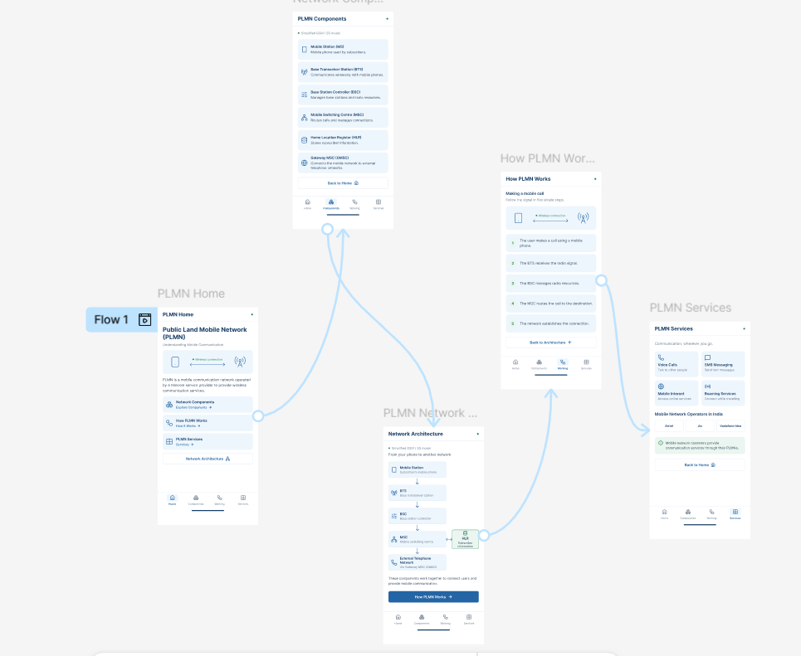
https://www.figma.com/design/ZRyw2okNT3ptO29B9DqRfA/Untitled?node-id=0-1&p=f&t=7V8NXOJ1ecOAWj2u-0

